## Glove with on-board PSU, electronics and sensors:

* Two finger glove for more mobility
* PSU around wrist
* Thin, large and flexible coils that can be hidden inside the fabric. Samwich the coil in thin adhesive film to give it structure and protect it.
* 3D printed modules and mounting mechanism (maybe use magnets to secure them).
* Coils as rings around the finger that would allow for fingerless gloves.

## Modules and applications:

* **Orientation module** - Stimulation depending on the direction faced. Could give directions towards a destination or knowledge of cardinal directions.  
  For walking back home -> the glove indicates the direction of home.
* **Distance/proximity module** - Navigation aid while blind or in darkness.  
  Three directional beam using tree sensors for individual stimulation.
* **Heart beat module** - A constant real-time feedback of your heartbeat in hope that the brain will learn to unconsciously process it and use it to regulate heart beat, blood circulation and breathing. It might also be helpful to develop the ability to consciously regulate your heartbeat as seen in diving. Might help in stress management and health improvement.
* **Microphone module** - directional hearing aid. Especially using ear implants.
* **Linear magnetic module** - A upragrade of the existing sense provided by the implants.  
  Must find a more sensitive sensor , 0-1000 microtesla range.
* **Heat/CO2/Radiation… modules** - Safety tool for workers or rescuers in specific conditions.
* **Light sensor module** - Aid in navigation and work tool.
* **Phone app or bluetooth module** - Notifications and ringing. Connection to any other wifi device and IOT. Gaming experience?
* **GPS** - For realtime hands-free navigation instructions. Could be used in location based games.
* **Radio and similar**- Can be used for hands free communication with three possible channels using individual stimulation.

## Alternatives:

* Sensors placed elsewhere on the body, (see behind your back idea cf. Mountaz)
* Bracelet idea, Everything included on a single piece bracelet (or sleeve)
  + Invisible under a sleeve and less intrusive.
  + No individual stimulation
  + Unstable field, depending on hand movement
  + Requires larger coil and more power

Phone only, through jack or BT to avoid arduino completely.

## Future experiments:

* Heart beat monitoring
* Sound interpretation
* Spatial representation
* GPS guidance

## 

## Ideas:

* UNDERSTANDING SOUND THROUGH THE GLOVE
* Ferrous magnetic glove elements to ease magnetic field propagation

## Lirmm/Research

INTERNSHIP WEEK 1

* Haptic feedback using implantable technology.

Main focus -> sensory substitution/addition

* + “We hypothesize that deaf participants who use the wristband will begin to show activation in their auditory cortex when feeling patterns of vibration on their wrist – in part because that will be the cortical territory available for takeover”
  + Can I use my implants as a plug and play “driver” to learn new “digital” senses?

Specificaly using magnets? Other methods (inductive coupling)?

* Creating a “sixth” fully independent sense.

Definition of sense? Defined by stimuli source or by sensing organ or something else?

INTERNSHIP WEEK 2

Focus points:

* The advantages of SMIs (no contact, portable, invisible) lead to an usage over long durations in everyday situations. The system can be compacted in a light weight, discreet wearable and could be used either as a haptic feedback device, a daily tool or an input for sensor information.
* Designing a more optimal implant.

Interniship goal: **Discreet wearable EDC device (haptic feedback, mobile phone periph., sensor feedback...). Especially oriented towards haptics.**

**Use cases brainstorm:**

-Finer pressure feedback when controlling robot.

-Virtual object touching using the Leap motion.

-Distance feedback using ultrasound distance sensor. (other environmental sensors too!)

-Basic phone connection for notifications/ringing...

-Advanced phone apps for hands free streaming of information, like navigation/gps instructions, maybe audio/music/voice. Feedback for games and general usage

**Two possibilities:**

* Onboard processing

Fully onboard processing for plug and play usage:

Using a Teensy3 for the onboard signal processing?

Onboard amplifiers and heat management.

High level data is received (coordinates, params...)

* Delegated processing

Simple bluetooth/wired audio in + amplifier. All processing has to be done by the emitter.

An audio signal is received.

Complete 3D freedom:

With a combination of a Leap Motion and a [Intel® RealSense™ Tracking Camera T265](https://www.intelrealsense.com/tracking-camera-t265/) we can obtain a very precise positioning of the hand in space with no constraints!!! Used for guidance, exploration of large environments (AR) etc...

Test for effect of the device on hand held electronics like phones and vr controllers.

Design brainstorm:

Bracelet (fully contained).

Glove with coils around fingers.

Rings on fingers with electronics somewhere else?

Device in users pocket, on the back of their phone, inside clothing.

Incorporated in a held object, in a remote for vr?

Bracelet:

**Two design options:**

**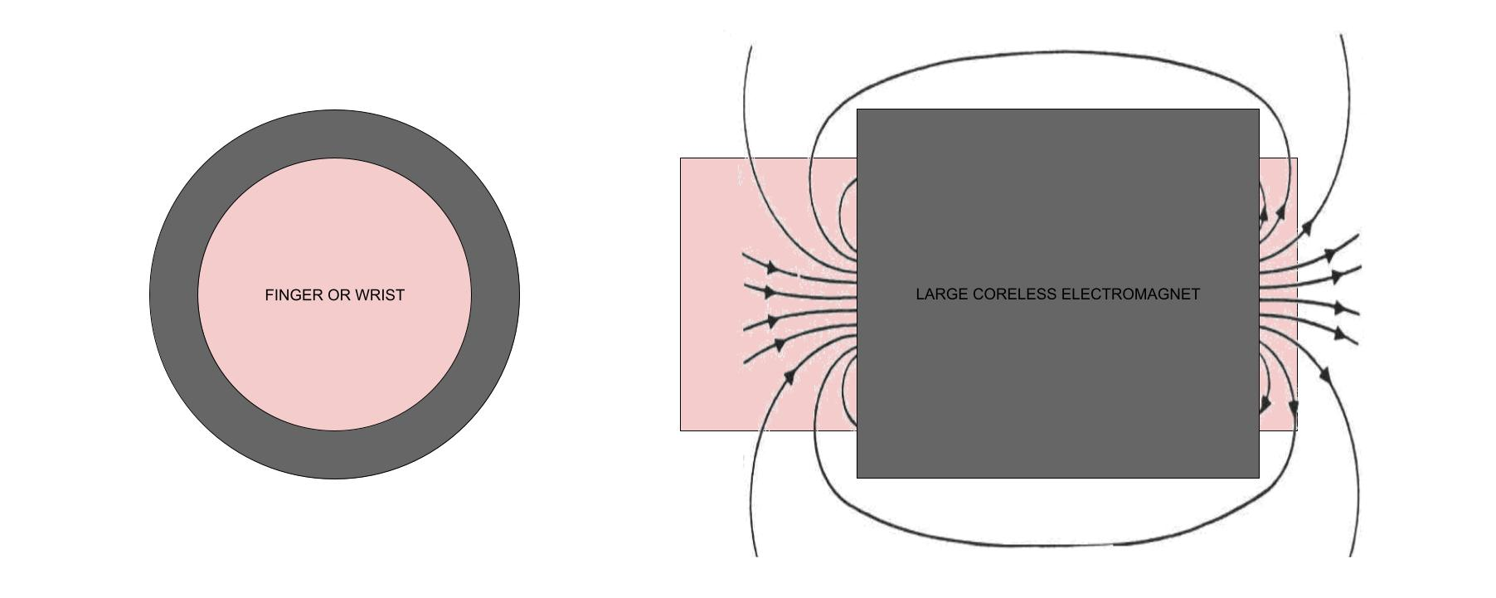**

Single:

+simpler

+more overal coil

-not openable

-not flexible

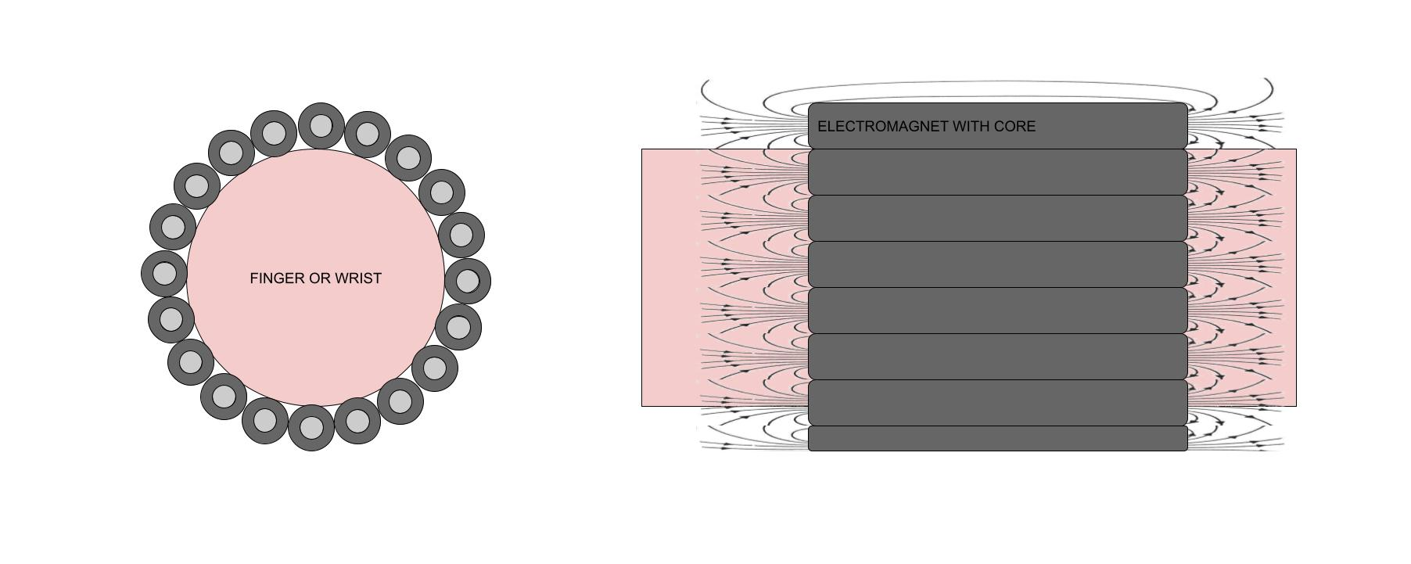

Multiple:

+openable

+flexible

+possibly available on the market

+maybe shapable field by individual control

+better heat management ??? (because of core and air gaps)

-possible interferences / messy field

But most importantly : EFFICIENCY???  
[http://hyperphysics.phy-astr.gsu.edu/hbase/magnetic/elemag.html#c5](http://hyperphysics.phy-astr.gsu.edu/hbase/magnetic/elemag.html" \l "c5)

Iron core is hundreds of times more efficient making option “multiple” the ideal one by far. (for the wrist at least)

Toroids? “*Toroids can also be placed near other electronic components without danger to damaging the devices because the magnetic field is constrained to the inside of the toroid.*” <https://questions.packback.co/questions/c3e0c2d5-58f5-407f-b100-ab59722e1688> SO NOT APPLICABLE.

**~~Check if FlexNext interferes with the devices field!!!~~**

[A look into future risks: A psychosocial theoretical framework for investigating the intention to practice body hacking](https://onlinelibrary.wiley.com/doi/full/10.1002/hbe2.176)

<https://www.mdpi.com/2409-9287/2/1/4>

<https://www.tandfonline.com/doi/abs/10.1080/14606925.2019.1594986>

[EM1338M3-1](https://www.first4magnets.com/magnet-materials-standard-assemblies-c150/12-7mm-dia-x-38-1mm-thick-electromagnet-with-3-5mm-mounting-hole-1-8kg-pull-12v-dc-1-4w-p12583" \l "ps_0_13318|ps_1_13250) : 12.7mm dia x 38.1mm

Pull force = 1.8 kg = 17.658 N = 3.969676331 lbf (pound force)

About 7382 Gauss or 738.2 mT ???

MK8/20 :



Pull force = 0.3 kg = 2.94 N = 0.6609383 lbf (pound force)

~~About 7397 Gauss or 739.7 mT ???~~

There is no real way to calculate the field strength, has to be measured

**Magnetic Suspension Coil with Iron Core**:

Not many sizes on the market. Can be DIYied

Probably better suited field

Used in audio -> more choice there

**FlexAR or similar flex actuator can be used for the xG3...**

**Rings VS Bracelet:**

|  |  |  |
| --- | --- | --- |
|  | RING | BRACELET |
| Stimulation | Individual | Global / 3D |
| Practicality | -- | +++ |
| Efficiency  (Estimated peak consumption) | +  1A | -  2-4A |
| Distance SMI to EM | 0-2 cm | 5-15 cm |
| Resting position relative to EM center axis | -  Offset to the side | +  Generaly centered |
| Max. Implant offset angle from EM axis | > 90° | < 90° |
| Estimated weight | 10-30g + battery | ??? + battery |
| Battery fits on device | MAYBE | YES |
| Can be air cored | YES | NO |

**Known data from Hameed and Harrison:**

We use different grades! 48 vs 52 => 20% strength increase

|  |  |  |  |
| --- | --- | --- | --- |
|  | Hameed | Harrison | Me |
| mT at finger surface | 12-20 |  | 40-44 |
| min stimulation Amplitude mT | 0.1 | 0.1 | ?? |
| Magnet grade | N48? | N48 | N52 |
|  |  |  |  |
|  |  |  |  |

**Points to discuss**

* N52 needs to be tested in comparison to the N48 from the papers in terms on sensitivity
* Need to start actual testing, calculations are unaccurate and depend on too many variables.
* Test: Actual range of small electromagnets (commercial EM10/10...) and same for air cored. Measure actual field strength and compare with theoretical.
* Different device arrangements – ring & bracelet comparison, rings are more polyvalent, bracelet is more practical.

**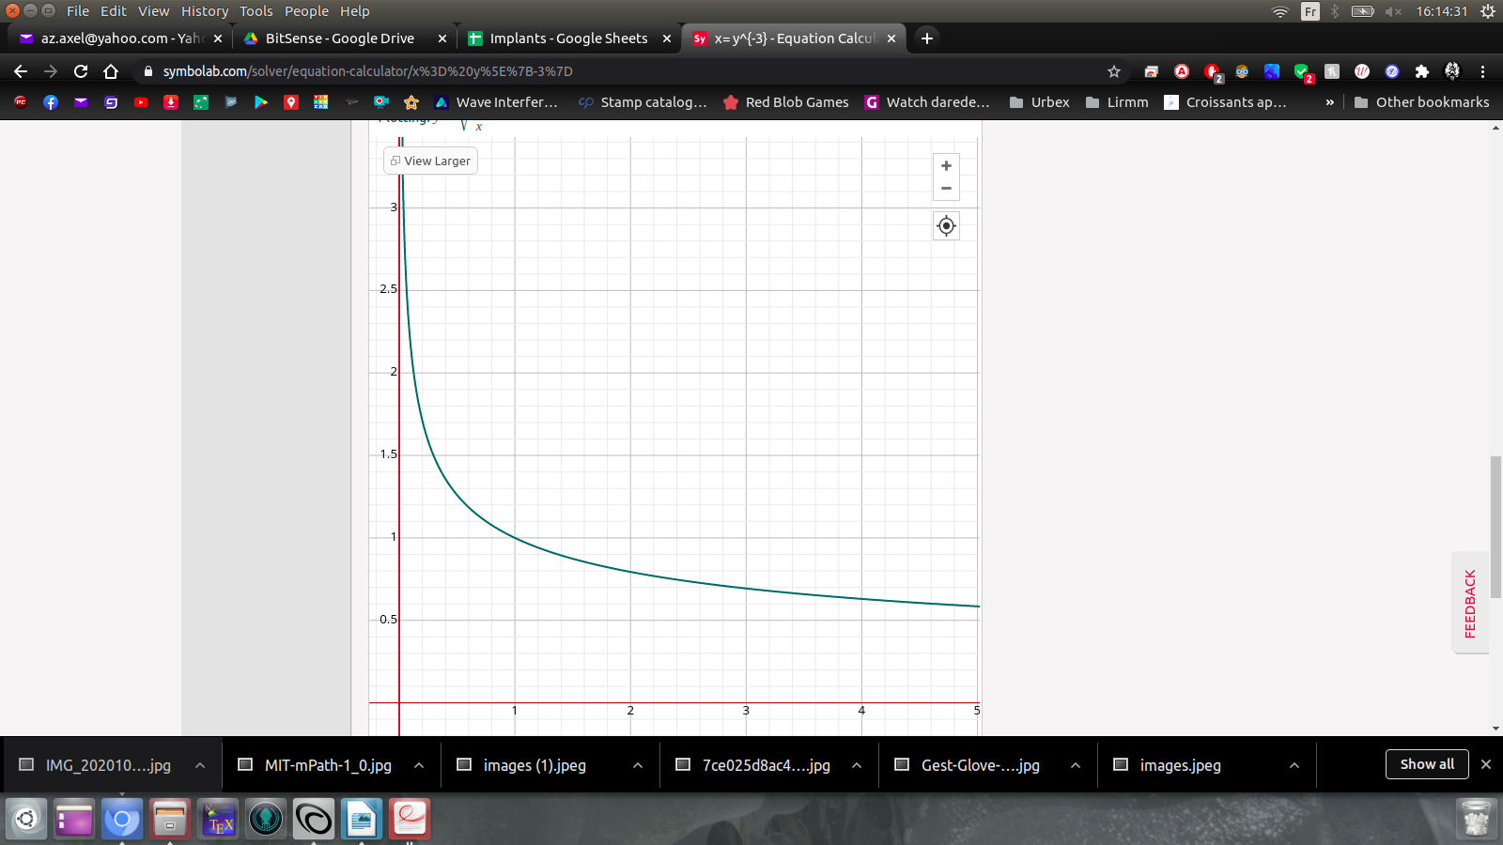**

**ALL mT calculations from here on are probably wrong**

Estimation of minimum flux density at the solenoid center to be noticable at the implant’s distnace (Based on Harrison’s 2018 paper and aproximate hand dimansions) real values will be much much higher due to misalignements (Field strength over distance follows the inverse cube law...):

**Bracelet estimation:**

min required field (pessimistic, actual is closer to 0.03mT): 0.1mT

distance (pessimistic): 15 cm

Minimum mT at source: 0.1 = S 1/15^3 : S = 150^3 \* 0.1 : S = 337500 mT (Not sure what units to use , I used mm and mT as the result made sense....)

**Ring estimation:**

min required field (pessimistic): 0.1mT

distance (pessimistic): 1.5 cm

Minimum mT at source: S = 15^3 : S = 337 mT

Graph of minimum source strength mT (y) over distance mm (x) for a field sterngth of 0.1mT

For 10mm => 100mT

For 20mm => 800mT

For 50mm => 12500mT or 12.5T (about 5 times an MRI)

This means the electromagnets seen earlier only give a range of less than two centimeters and not 15cm...

**WRONG**

**Trying to estimate the necessary surface field strength to get a minimum strength at a fixed distance doesn’t even make sense.**

**Because it depends on every single specification of the electromagnet and is only valid on the z axis of said EM.**

**Most (all?) magnetic formulas are rough aproximations (maybe beacause of how dependent they are on physical variables?)?**

**The results I’m getting are either completely ridiculous or proven wrong in practice.**

**I can not really estimate the necessary electromagnet without proper testing**

But I have already tested multiple setups and know aproximately what to expect:

For full range stimulation at 1cm (in ring shape where the implant is offset to the side), I have used an air-cored solenoid, aproximately 80 turns , length 10mm and max Intensity 1A from that I can calculate a 10mT maximum field at the center.

For full range stimulation at 5cm (large coil with implant perfectly centered), I have used an air-cored solenoid, aproximately 30 turns , length 10mm and max Intensity 3A from that I can calculate a 11.31mT maximum field at the center.

To do:

* Determine sensitivity to field strength with N52 and frequency sensitivity using methods from Hameed..
* Determine optimal ring coil specs for range (compare measurements with theoretical, if they match we can then calculate optimal specs)
  + Test peak amperage for selected wire (sources are contradictory)
  + Test diameter and length
  + Test behavior over frequency spectrum

Aside - industrial pulling magnets testing:

* Take measurements to get an estimation of the Newton to range ratio
* Try to remove bottom face (as seen in zhang2016ieee) to improve field
* Check efficiency on low frequency AC.

# Conclusions from simulations:

Theoretical is 1.3-1.4 times more optimistic compared to simulation values. This is not very surprising as the formulas are estimations...

With fixed overall dimensions:

1. L core provides best results on z axis, followed by (in order):
2. U core
3. internal ring core,
4. II core
5. full coil
6. external ring core

## Getting to know the new equipment and pullMagnet quick tests:

The Teslameter does in DC PEAK and AC PEAK modes keeps increasing until it maxes out, weird.

The 16\*24 EM has about 40mT surface strength, that is a similar value to the theoretical strength of the rings I plan on making. But the field is probably shaped differently so ranges might not be comparable.

On the 70V setting the 16\*24 can be easily felt at 4cm but does heat up after a minute with 78mT at the surface and 0.36mT at 2cm indicating that potentially the threshold with modern implants is much lower.

~~My sensitivity threshold might be too low to measure !?? Teslameter resolution is suposed to be 2 uT / 0.002mT!~~ Also resolution seems to be worse over low freqs.... :(

Measured mT for barely perceptible 100Hz sine = 0 - 0.005 mT => the gaussMeter’s limit (should try again with axial probe)

For 4 Ohms -> about 200 turns of AWG 29 with 23mm diam.

### Ideal ring:

16mm inner

AWG 28

4 Ohms -> 0.0135 Ohms / turn -> aprox 300 turns -> Too much (maybe add 2 Ohm resistor or use low impedance amp). Should try and keep reactance low.

I made a quick test rig: 4mm length, 23mm diam, 50 turns, at 1.157V and an estimated 0.96974 Ohms and calculated 1.1931 A it is supposed to give 18.74 mT at surface. I could feel all frequencies from 1cm with a peak sensitivity on 300Hz that could be felt comfortably at 4cm.

Mesaured at 300Hz -> 2.3 mT (more or similar to the 16\*24 EM)

I 3Dprinted a little device to help make the ring coils. It has adjustable coil length (2-15mm) and adustable coil width (2,3 and 4 mm).

On low resistance coils a additional resistance is needed. There is no real point in using thicker AGWs, they just need more current for similar results. We’re going to us 28 AWG or similar and have custom industrially made coils because handmade ones are ineficient.

2-5W stereo bluetooth amp should be enough, the poor results I had before were because I was making the solenoid longer rather than wider (see formula for magnetic field strength of a solenoid).

The L shaped core in iron or ferrite might be necessary if we want to keep the ring thin or increase the range.

[BT Receiver](https://fr.farnell.com/microchip/rn4871u-v-rm118/module-bluetooth-v4-2-2-402-2/dp/2851698?gclid=Cj0KCQjwi7yCBhDJARIsAMWFScOpx_1oqjeCX74LaPl6UWlsId5uA91vBBti9M42l8btUPIu_cqpNnoaAtSpEALw_wcB&mckv=sr35UueYF_dc|pcrid|459805093572|plid||kword||match||slid||product|2851698|pgrid|108011007256|ptaid|pla-300106027886|&CMP=KNC-GFR-SHOPPING-SMEC-01-Mar-21_Desk-Hi&gross_price=true)

[Amplifier](https://www.ptrobotics.com/modulo-de-som/2790-stereo-28w-class-d-audio-amplifier-i2c-control-agc-tpa2016.html)

Throughout the testing I never managed to reach the pain threshold with the 250W amplifier, although the center of a large coil with a lot of power can cause discomfort. In our application we are far from those frequencies and therefore do not have to worry about that.

I tested frequency sensitivity with different signals and the following param: 10Hz to 400Hz,

I used the measured amperage as the test value since all other factors in the field strength calculation are constant it should be directly proportional to the strength but still measured rather than aproximated.

I took the readings by adjusting the amplifiers dB output until the signal was percievable and continuous to my index finger. My index finger was placed at a fixed distance from the center of the flat coil on the z axis.

The results were slightly different for each signal. The most sensitive range overall being 50-300Hz as expected. Also all signals lose sensitivity rapidly over 300Hz.  
The SAW (and SQUARE but less) wave, as opposed to the SINE remains as sensitive (even more in fact) in frequencies lower than 50Hz. While the SINE is the least optimal for lower frequencies.

To be noted: In frequencies under 50Hz the sensation goes from a buzz to a fast beat and under 30Hz it feels like a continuous slow deformation of the the tissues, similar to rolling a ball bearing on the skin but on the inside.

This all makes sense, in lower frequencies the sharp drops in the SAW wave produce a fast change in polarity similar to what happens at high frequencies on a SINE. In Higher frequencies where the changes in polarity are to close to be sensed all waves behave similarly. With this logic the SQUARE (and SAW but less) wave sould be felt better in the higher frequencies as the changes in polarity are further appart and indeed it does slightly better.

The reason SAW is less sensitive than SQUARE in high frequencies might be that the sharp polarity change is always in the same direction and contrary to low frequencies the implant does not get enough time + energy to move all the way back.

Why is SQARE not as good as SAW in LF?

In Harrison2018 amplitude detection was only tested on two frequencies, here I test them over a range. Nevertheless the higher sensitivity at 200Hz than 20Hz (Amplitude RL results) is similar to my results.

|  |  |  |
| --- | --- | --- |
| Incoherent | I | Hard to recognize the signal. Noise or a continuous signal with spikes in amplitude. Like holding a bee. |
| Continuous | C | Feels like lightly sliding the finger across smooth fabric or very soft fur. |
| Vibration | V | A soft vibration of discernable frequency, not very localized and fades throughout the finger. Can feel like rough fabric or running. |
| Buzz | B | A sharp vibration that reverberates through the bone. A pull on the magnet's area can be felt at the same time. Feels like touching a running engine or running your fingers along a fence. |
| Tapping | T | A sensation of being hit or tapped at the implant's location at a speed equivalent to the frequency used. |
| Deformation | D | Feels like something is crawling under the skin, similar to rubbing the finger on a surface of small beads (Hard bubble wrap) |
| Pull | P | Very localized feeling of the implant being attracted in a direction (the direction can be hard to determine). It is a continuous version of "Tapping" but the mechanoreceptors get used to it so quickly that it takes a lot of power to be felt reliably |

Square waves on low frequencies (<20Hz) tend to produce T with a bit of D. Over 20Hz the sensation turns into V or B . With lighter signals and progressively more as frequency increases it turns into a very smooth C.

At any frequency a signal that is too strong turns into an unpleasant B.

Sawtooth waves on low freqs produce a very sharp D that transition very quickly through T and B when increasing freq to end in a very clean and sharp C.

Again at any frequency a signal that is too strong turns into an unpleasant B.

A triangle wave is noisier in C and makes D much much smoother.

Sine waves produce strong but smooth D in low freqs (<20Hz) that almost feel like the entire finger tip is being shaken. Then quickly transitions to a relatively smooth B from 30Hz to 100Hz and from 100Hz to 200Hz we transition form B to C. Under 200Hz a large amplitude will produce a B but over that it is just a C getting stronger. This makes sines much more pleasant in high amplitudes.

Observation: Although being a bit less sensitive on very weak signals the deeper implanted SMI is overall more enjoyable. The signals feel smoother and there is less unpleasant deformation on very strong amplitudes.

WEEK 8 conclusions

* Implant strength at surface is doubled (compared to Hameed) 40mT
* Field strength sensitivity < 0.005mT (previous 0.03mT, 6 times better?)
* Explored sensitivity in relation to frequency and signal type
* Rings are feasable (though they would have to be industrially made to improve range)

[**https://tel.archives-ouvertes.fr/tel-00665261/document**](https://tel.archives-ouvertes.fr/tel-00665261/document)

Perceptual Dimensions of texture:

- smooth - rough

- hard - soft

- sticky - slippery

- warm - cold

(there are cross-correlations)

Yoshioka et al. -> roughness, hardness and stickiness through vidbration

[**https://tel.archives-ouvertes.fr/tel-01360590/document**](https://tel.archives-ouvertes.fr/tel-01360590/document)

[**https://www.ncbi.nlm.nih.gov/pmc/articles/PMC2074877/**](https://www.ncbi.nlm.nih.gov/pmc/articles/PMC2074877/)

"We examined quantitatively how “peak frequency” varied as a function of spatial period. The peak frequency corresponding to a given surface was the frequency of the largest Fourier component after subtraction of the null spectrum and Pacinian weighting. The peak frequency of each surface was then compared with its natural frequency, i.e., to the rate at which surface elements will be scanned under a given point on the skin. Natural frequency is proportional to belt speed and inversely related to spatial period:

**F = scanning speed / spatial period** "

*That is exacty the formula I used intuitively! I need to rename my variables to the conventional terms.The issue is I used this frequency to modulate a base pressure linked frequency (I did this to be able to give feedback even when there is no perpendicular movement). I should maybe used the natural frequency as base modulated in amplitude by the pressure and deal with the static pressure independently.*

So the simulation of a texture while moving the fingertip accross a surface is valid and only limited by the leapMotion's spatial resolution. The real issue is the static feedback of pressure... I originaly used a high frequency (350Hz) indended to be felt like a smooth continuous pressure but it interfered too much with the texture feedback. Ideally I would use a strong DC signal but that is not possible with the current setup. I will try to use very low frequencies as I did for liquids but it is difficult to get the appropriate intensity.

[**https://hal.archives-ouvertes.fr/hal-02611574/document**](https://hal.archives-ouvertes.fr/hal-02611574/document)

Amicrocontroller (Teensy 3.5) reads the encoder and outputsa modulating signal according to a friction map encodedin memory on a fixed real-time timer. The carrier signal, a35 kHz sine wave, is created by a function generator (BKPrecision 4052) and amplitude modulated by the analogsignal coming from the microcontroller. The resulting signalis then amplified 20-fold (WMA-100, Falco Systems) to drivetwo piezoelectric actuators glued on a105×22×3.3 mmglass plate. Modulation of the amplitude of vibration of theglass plate induces friction variations during exploration.

The presentation order of thevelocity condition was alternated between subjects. For the50 mm/s velocity, haptic stimuli were rendered for 7 spatialperiods: 0.125, 0.25, 0.5, 1, 2, 4 and 8 mm. For the 100 mm/svelocity, haptic stimuli were rendered for 6 spatial periods:0.25, 0.5, 1, 2, 4 and 8 mm. According to the 2 fingervelocities, the vibrations transmitted to the finger variedfrom 6.25 Hz to 400 Hz. The 0.125 mm condition wasnot presented for the high velocity since it would producea fundamental frequency of 800 Hz, which could not berendered by the glass plate. The spatial period sessionswere presented in random order. The experiment lasted forapproximately 2 hours.

[**https://engineering.purdue.edu/~hongtan/pubs/PDFfiles/J50\_NellyChen\_etal\_ToH2011.pdf**](https://engineering.purdue.edu/~hongtan/pubs/PDFfiles/J50_NellyChen_etal_ToH2011.pdf)

To determine the shape of waveforms for driving thepiezoelectric actuator, acceleration profiles of pop-domekeys on a telephone, a computer keyboard, and a cellphone were measured. Fig. 2a shows a typical recordingfrom the keypad of an office phone during the key-downphase. There is a clear initial pulse, followed by several“ringing” pulses with diminishing amplitudes. Based onthe measurements, raised sinusoidal waveforms were usedto drive the piezoelectric actuator (see Fig. 2b).A series of preliminary experiments were conducted todetermine the relevant parameters for generating key-clicksignals on the piezoelectric actuator. Among the variablesconsidered were peak amplitude, frequency, number ofcycles, initial/peak velocity, and initial/peak acceleration.Measurements were also taken to examine the transferfunction of the piezoelectric actuator. In the interest ofspace, readers are referred to the [Appendices, 28] fordetails. In the end, three parameters were found toinfluence the perceived quality of simulated key clicks:amplitude, frequency, and number of cycles of thesinusoidal waveform. Amplitude of the waveform con-tributed to the overall perceived intensity of a key-clicksignal. The maximum amplitude was 200 V using thesetup described in Section 2.1. Frequency of the waveformdetermined the perceived “crispness” of a key-click signal.The frequency range was selected to be 125-500 Hz thatcorresponded to perceptually “dull” to “crisp” key clicks.Finally, the number of cycles also contributed to theperceived intensity of the signal, but more than threecycles resulted in an eerie sensation of something alive.Therefore, the number of cycles ranged from 1 to 3 in thepresent study.

Fingertip position filtering idea: maybe filter x, y and z components (relative to the surface) separately instead of filtering the whole position?

**On blind shape exploration using SMIS:**

It is quite easy to feel the sides of a cube and quickly create a mental image of the object in space. I found that seeing the hand in space helps a lot with spatial awareness and makes the exploration more fluid and precise.

The fact that there is no real phisycal obstacles (the hand can go through and behind the shape) make for a different way of exploring space. I found that even though I hat the freedom of going though the shape I tended to keep my hand outside, palm towards the surface. Of course the orientation and position of the hand and fingers do not matter at all in this environment and maybe once the habit of touching a physical sufrace has been surpassed then new and more efficient ways of exploring space will occur. For now a poking gesture is the most effective at determining a surface. Sliding allows to find the edges (this is without any visual aid of course).

**On the printed rings and inductors:**

There doesn’t seem to be any advantage in using multiple axial inductors (both parallel and aligned). I use a single inductor with a resistance of about 15 Ohms that can be driven with a 11W amplifier (5W amps could not be used). The field is slightly lesser thant that of the previously used coil but when the inductor is held close to the implant <1 cm the field is very consistent and sufficient for haptics. Another andvantage is the largely reduced size of the ring and the possibility for it to be open.

SMIS Updates:

Tech limitations on the texture feedback: tracking imprecisions, no simulated friction and impossibility to created a strong DC field through standard audio for the pressure effect.

A convincing button feedback is easy to setup by just using the audio recording of such button as the feedback signal.

TO BE VERIFIED EXPERIMENTALY:

* **Lower sensitivity threshold for modern SMIs @20,100 and 200 Hz**

By sending stimuli of varying strength in a range close to the estimated threshold and asking wether or not a stimuli was felt. With a pause in between each stimuli. The setup does not matter that much as long as it is consistent throughout the experiment. A horizontal coil will allow to measure the field at the same time.

* **Sensitivity threshold curves for SINE, SQUARE and SAW signals**

Same as previous but with many frequencies on each signal (this might take a long time).

* **(Maybe validate my chart describing feedback sensations).**

Ask subject to categorize a stimuli in one of the predefined categories. See if answers match between subjects.

* **Texture discrimination (NO?)**

Provide an array of textured objects, some textures are identical and some are different (no visible difference). Ask the subject which are different. We can find out the minimum spatial frequency difference necessary to discriminate textures by analysing the results.

* **3D shape recognition**

Present a 3D shape to the subject, ask what it is. (there shouldn’t be a time limit).

Maybe do a 1 vs 2 finger comparison.

* **Sensor related apps like compass or blind navigation using ultrasound**

App dependent

REVISED:

Discrimination of objects relative to their scale (spatial resolution)

Hardness discrimination (signal resolution)

Effectiveness of feedback

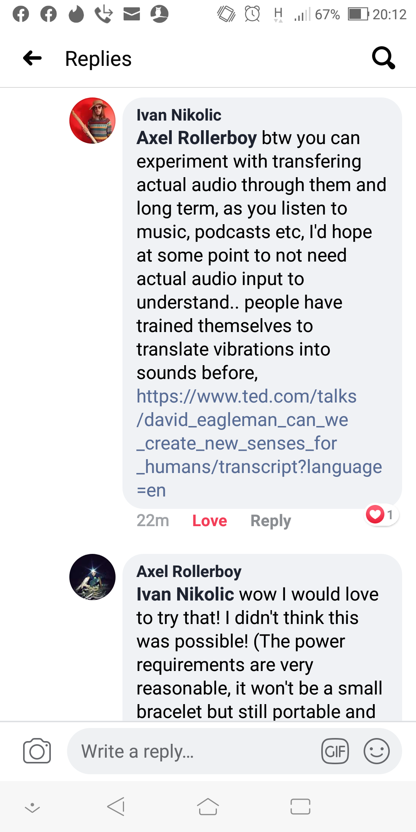

<https://www.ted.com/talks/david_eagleman_can_we_create_new_senses_for_humans/transcript?language=en>

* The umwelt

[https://www.ted.com/talks/david\_eagleman\_can\_we\_create\_new\_senses\_for\_humans/transcript?language=en#t-171398](https://www.ted.com/talks/david_eagleman_can_we_create_new_senses_for_humans/transcript?language=en" \l "t-171398)

<https://www.nature.com/articles/ncomms7080>

<https://www.youtube.com/watch?v=o4cgpQUW8HI&ab_channel=ubicompla>